**VELAMMAL BODHI CAMPUS**

**GRAND TEST – I**

**Class : X Duration : 3 Hrs.**

**Subject : Maths – Batch II Maximum marks : 80**

**General Instructions:**

1. *This Question Paper has 5 Sections A, B, C, D and E.*
2. *Section A has 20 MCQs carrying 1 mark each*
3. *Section B has 5 questions carrying 02 marks each.*
4. *Section C has 6 questions carrying 03 marks each.*
5. *Section D has 4 questions carrying 05 marks each.*
6. *Section E has 3 case based integrated units of assessment (04 marks each) with sub- parts of the values of 1, 1 and 2 marks each respectively.*
7. *All Questions are compulsory. However, an internal choice in 2 Qs of 5 marks, 2 Qs of 3marks and 2 Questions of 2 marks has been provided. An internal choice has been provided in the 2marks questions of Section E*
8. *Draw neat figures wherever required. Take π =22/7 wherever required if not stated.*

**SECTION-A**

**I. Section A consists of 20 questions of 1 mark each.**

1. If HCF(26,169)=13, then LCM(26,169) is

(a) 26 (b) 52 (c) 338 (d) 13

1. A quadratic polynomial whose zeroes are – 3 and 4, is:

(a) x2– x + 12 (b) x2 + x + 12 (c) x2 – x – 12 (d) 2x2+ 2x – 9

1. The value of k, for which the system of equations 3x – ky – 20 = 0 and

6x – 10y + 40 = 0 has no solution, is:

(a) 10 (b) 6 (c) 5 (d) 3

1. The mid-point of segment AB is the point P(0, 4). If the coordinates of B are

(– 2, 3), then the coordinates of A are:

(a) (2, 5) (b) (– 2, – 5) (c) (2, 9) (d) (– 2, 11)

1. A bag contains 3 red balls, 5 white balls, and 7 black balls. What is the

probability that a ball drawn from the bag at random will be neither red not black?

(a) $\frac{1}{3}$ (b) $\frac{8}{15}$ (c) $\frac{7}{15}$ (d) $\frac{1}{5}$

1. The numerical value of ($\frac{1}{\cos{θ}}+\frac{1}{\cot{θ}})(\frac{1}{\cos{θ}}-\frac{1}{\cot{θ}})$

(a) 0 (b) 1 (c) -2 (d) -1

1. The distance between the points A(0,6) and B(0,-2) is

(a) 6 units (b) 8 units (c) 4 units (d) 2 units

1. If the difference between the circumference and the radius of a circle is 37 cm,

the radius of the circle (in cm) is:

(a) 154 (b) 44 (c) 14 (d) 7

1. The nth  term of an AP a, 3a,5a,… is

(a) n a (b) (2n-1)a (c) (2n+1)a (d) 2n a

1. One ticket is drawn at random from a bag containing tickets numbered 1 to 40.

The probability that the selected ticket has a number that is a multiple of 7 is:

(a) $\frac{1}{7}$ (b) $\frac{1}{8}$ (c) $\frac{1}{5}$ (d) $\frac{7}{40}$

1. The nature of roots of the quadratic equation 9x2 – 6x – 2 = 0 is:

(a) No real roots (b) 2 equal real roots

(c) 2 distinct real roots (d) More than 2 real roots

1. If 5 tanβ =4, then $\frac{5 sinβ-2 cosβ}{5 sinβ+2 cosβ }$ =

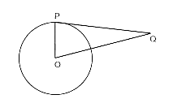(a) 1/3 (b) 2/5 (c) 3/5 (d) 6

1. From a point Q, 13 cm away from the centre of a circle, the

length of tangent PQ to the circle is 12 cm. The radius of the circle (in cm) is:

(a) 25 (b) 5 (c)1 (d) $√313$

1. What is the angle subtended at the centre of a circle of radius 10cm by an arc of

length 5 $π$ cm?

(a) 60 $°$ (b) 45 $°$ (c) 90 $°$ (d) 120 $°$

1. In $∆ABC , ∆DEF$ $∠F=∠C, ∠B=∠E$ and AB= $\frac{1}{2}DE$, then the two triangles are

(a) Congruent but not similar (b) Similar but not congruent

(c) Neither similar not congruent (d) congruent as well as similar

1. If the value of mean and mode are 30 and 15, respectively, then median will be:

(a) 25 (b) 24 (c) 23.5 (d) 26

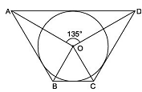

1. In the given figure, if ∠AOD = 135°, then ∠BOC is equal to:

(a) 52.5° (b) 45° (c) 62.5° (d) 25°

1. If $\sin{A=\frac{1}{2}},$ then what is Cot A

(a) $√3$ (b) $\frac{1}{√3}$ (c) $\frac{√3}{2}$ (d) 1

1. **ASSERTION (A):** A hemisphere of radius 7 cm is to be painted outside on the

surface. The total cost of painting at it Rs. 5 per cm2  is Rs. 2300.

**REASON (R) :** The total surface area hemisphere is 3πr2.

(a) Both A and R are true, and R is the correct explanation of A.

(b) Both A and R are true, but R is not the correct explanation of A.

(c) A is true, R is false.

(d) A is false, R is true.

1. **ASSERTION (A)**: a, b, c are in A.P. if and only if 2b = a + c.

**REASON (R)** : The sum of first n odd natural numbers is n2.

(a) Both A and R are true, and R is the correct explanation of A.

(b) Both A and R are true, but R is not the correct explanation of A.

(c) A is true, R is false.

(d) A is false, R is true.

**SECTION-B**

**II. Section B consists of 5 questions of 2 marks each.**

1. 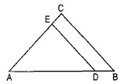The HCF and LCM of two numbers are 9 and 360 respectively if one number is 45. Find the other number.
2. In fig. DE $∥BC.$ If AD=x cm, DB= (x-2) cm , AE=(x+2)cm and EC=(x-1)cm. Find the value of x.
3. **If $\tan{θ=\frac{3}{4},}$** then find the value of $\frac{1}{\sin{A}}+\frac{1}{\cos{A}}$

(or)

Evaluate : $\frac{{5cos}^{2}60°+4\sec^{2}30°-\tan^{2}45°}{\sin^{2} 30°+\cos^{2}30°}$

1. Prove that the parallelogram circumscribing a circle is Rhombus.
2. A horse is tied to a peg of one corner of a square shaped grass field of side 15m by means of a 5m long rope. Find the area of that part of the field in which the horse can graze.

(or)

Find the area of a quadrant of a circle whose circumference is 88 cm.

**SECTION-C**

**III. Section C consists of 6 questions of 3 marks each**

1. Prove that 5+3 $√2$ is an irrational number.
2. The sum of a two digit number and the number obtained by reversing the digits

is 66. If the digits of the number differ by 2, find the number. How many such numbers are there?

(Or)

Solve the following system of linear equations graphically : x – y + 1 = 0 and

3x + 2y – 12 = 0. Calculate the area of the region bounded by these lines and the X-axis.

1. If $α$, β are zeroes of quadratic polynomial 5x2+ 5x + 1, find the value of

(i) $α^{2}+β^{2}$ (ii) $\frac{1}{α}+\frac{1}{β}$

1. Prove that : (cosec A – sin A)(sec A-cos A) = $\frac{1}{\tan{A}+\cot{A}}$.
2. The mean of the following distribution is 18. Find the frequency f of the

class 19-21.

|  |  |  |  |  |  |  |  |
| --- | --- | --- | --- | --- | --- | --- | --- |
| Class | 11-13 | 13-15 | 15-17 | 17-19 | 19-21 | 21-23 | 23-25 |
| Frequency | 3 | 6 | 9 | 13 | f | 5 | 4 |

1. If a circle touches the side BC of a triangle ABC at P and extended sides AB and

AC at Q and R, respectively, prove that AQ = 1/2 perimeter of triangle ABC

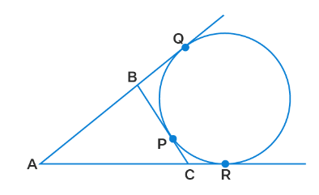

(or)

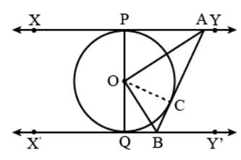In the given figure, XY and X'Y' are two parallel tangents to a circle with centre O and another tangent AB with point of contact C intersects XY at A and X'Y' at B. Then prove that ∠ AOB=90 $°$.

**SECTION-D**

**IV. Section D consists of 4 questions of 5 marks each**

1. A train, travelling at a uniform speed for 360 km, would have taken 48 minutes

less to travel the same distance if its speed were 5 km/hr more. Find the original sped of the train.

(or)

(i) Solve for *x*: ${9x}^{2}-9\left(a+b\right)x+\left({2a}^{2}+5ab+{2b}^{2}\right)=0$

(ii) If -5 is a root of the quadratic equation 2x2 + px – 15 = 0 and the quadratic equation p(x2 + x) + k = 0 has equal roots, find the value of k.

1. State and Prove Basic Proportionality theorem. And prove that the line joining

the midpoints of any two sides of a triangle is parallel to the third side.

1. 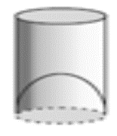A juice seller was serving his customers using glasses as

shown in Fig. The inner diameter of the cylindrical glass was 5 cm, but the bottom of the glass had a hemispherical raised portion which reduced the capacity of the glass. If the height of a glass was 10 cm, find the apparent capacity of the glass and its actual capacity. (Use π=3.14).

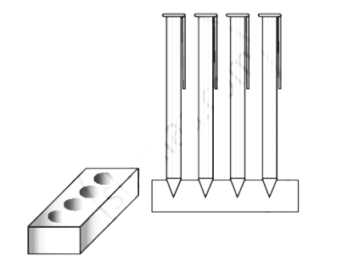 (or)

A pen stand made of wood is in the shape of a cuboid with four conical depressions to hold pens. The dimension of the cuboid are 15cm by 10cm by 3.5cm. The radius of each of the conical depressions is 0.5 cm and the depth is 1.4 cm. Find the volume of the wood in the entire stand.

1. In the frequency distribution table , the sum of all frequencies is 230 and the

median value is 46. Find the missing frequencies x and y. And thereby find out the mode.

|  |  |  |  |  |  |  |  |
| --- | --- | --- | --- | --- | --- | --- | --- |
| VARIABLE | 10-20 | 20-30 | 30-40 | 40-50 | 50-60 | 60-70 | 70-80 |
| FREQUENCY | 12 | 30 | X | 65 | Y | 25 | 18 |

**SECTION-E (Case Study Based Questions)**

1. **Section E consists of 3 questions of 4 marks each**
2. Deepa has to buy a scooty. She can buy scooty either making cashdown payment

of Rs. 25,000 or by making 15 monthly instalments as below.

Ist month-Rs. 3425, IInd Month – Rs. 3225, IIIrd month – Rs. 3025,

IVth month - Rs. 2825 and so on.



1. Find the amount of 6th instalment. (1)
2. Total amount pain in 15 instalments. (1)
3. If Deepa pays Rs.2625, then find the number of instalments (2)

(or)

Deepa paid 10th and 11th instalments together then find the amount paid that month.

1. Basant and Vinod lives in a housing society in Dwarka, New Delhi. There are two

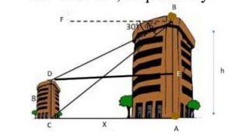building in their housing society. The first building is 8 meter tall, One day, both of them were just trying to guess the height of the other multi-storeyed building. Vinod said that it might be a 45 $°$ angle from the bottom of our building to the top of multi-storeyed building so the height of the building and distance from our building to this multi-storeyed building will be same. Then, both of them decided to estimate it using some trigonometric tools. Let's assume that the first angles of depression of the top and bottom of an 8 m tall building from top of a multi-storeyed building are 30 $° and$ 45 $°$ respectively.

1. Now help Vinod and Basant to find the height of the multistoried building. (1)
2. Find the distance between two buildings. (1)
3. Find the distance between top of multistoried building and top of first building.

(2)

(or)

Find the distance between top of multistoried building and bottom of first building.

1. Jagdish has a field which is in the shape of a right angled triangle AQC. He wants

to leave a space in the form of a square PQRS inside the field for growing wheat and the remaining for growing vegetables (as shown in the figure). In the field, there is a pole marked as O.

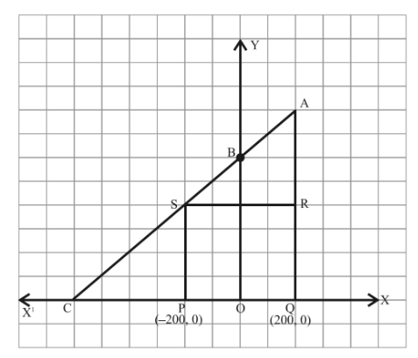

1. Taking O as origin, coordinates of P are (-200, 0) and of Q are (200, 0). PQRS

being a square, what are the coordinates of R and S ? (1)

1. If S divides CA in the ratio K:1, what is the value of K, where point A is

(200, 800)? (1)

1. What is the area of square PQRS ? (2)

OR

What is the length of diagonal PR in square PQRS?